Project Design Phase-II

Data Flow Diagram & User Stories

|  |  |
| --- | --- |
| Team ID | PNT2022TMID50449 |
| Project Name | Project - Real-Time Communication System Powered by AI for Specially Abled |
| Maximum Marks | 4 Marks |

# Data Flow Diagrams:

A Data Flow Diagram (DFD) is a traditional visual representation of the information flows within a system. A neat and clear DFD can depict the right amount of the system requirement graphically. It shows how data enters and leaves the system, what changes the information, and where data is stored.

# Example: (Simplified)

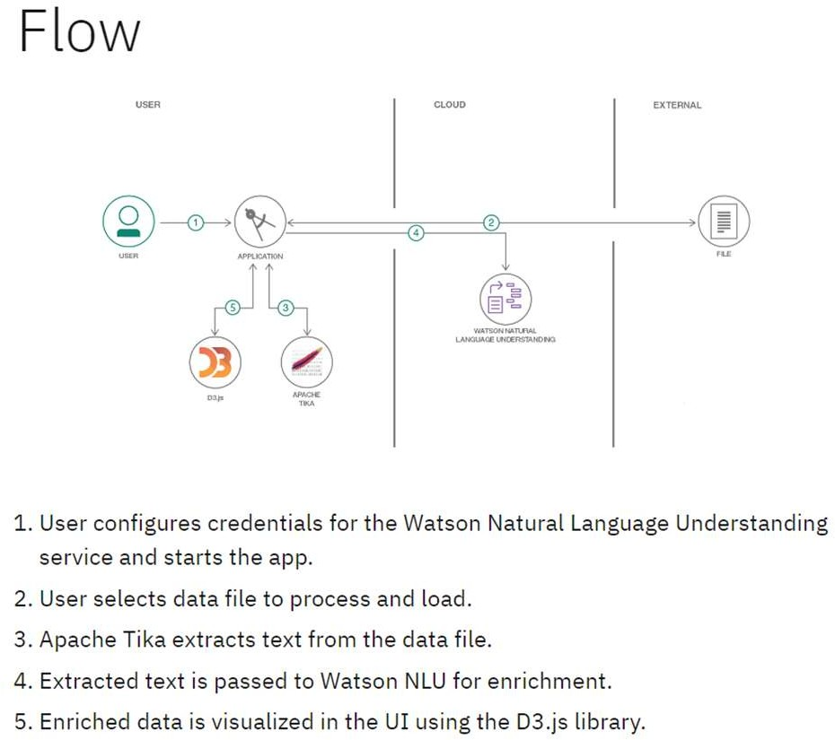

**User Stories**

Use the below template to list all the user stories for the product.

|  |  |  |  |  |  |  |
| --- | --- | --- | --- | --- | --- | --- |
| **User Type** | **Functional Requirement (Epic)** | **User Story Number** | **User Story / Task** | **Acceptance criteria** | **Priority** | **Release** |
| User (Deaf & Dumb Person) | Registration | USN-1 | As a user, I can register for the application by entering my email, password, and confirming  my password. | I can access my account / dashboard | High | Sprint-1 |
|  |  | USN-2 | As a user, I will receive confirmation email once I have registered for the application | I can receive confirmation email & click confirm | High | Sprint-1 |
|  |  | USN-3 | As a user, I can register for the application through Gmail | I can access my account / dashboard via Gmail | Medium | Sprint-2 |
|  | Login | USN-4 | As a user, I can log into the application by entering email & password | I will be redirected to my dashboard | High | Sprint-1 |
|  | Dashboard | USN-5 | As a user, I can view a menu to perform sign- language to speech conversion | I will be redirected to the  appropriate page on making my selection | High | Sprint-2 |
|  | Image Upload | USN-6 | I will be provided with an option to upload an image of the sign-language in jpeg / png format | I will get a confirmation that the image has been uploaded successfully and  can preview the image | High | Sprint-2 |
|  | Translation | USN-7 | I will be provided with a button to initiate the translation process | I will be able to play an audio file containing the converted output | High | Sprint-3 |
| User (Normal Person) | Registration | USN-8 | As a user, I can register for the application by entering my email, password, and confirming my password. | I can access my account / dashboard | High | Sprint-1 |
|  |  | USN-9 | As a user, I will receive confirmation email once I have registered for the application | I can receive confirmation email & click confirm | High | Sprint-1 |
|  |  | USN-10 | As a user, I can register for the application through Gmail | I can access my account / dashboard via Gmail | Medium | Sprint-2 |
|  | Login | USN-11 | As a user, I can log into the application by entering email & password | I will be redirected to my dashboard | High | Sprint-1 |
|  | Dashboard | USN-12 | As a user, I can view a menu to perform sign- language to speech conversion | I will be redirected to the  appropriate page on making my selection | High | Sprint-2 |

|  |  |  |  |  |  |  |
| --- | --- | --- | --- | --- | --- | --- |
| **User Type** | **Functional Requirement**  **(Epic)** | **User Story Number** | **User Story / Task** | **Acceptance criteria** | **Priority** | **Release** |
|  | Text Entry | USN-13 | I will be provided with a text box to type in the input | I can preview the entered text | High | Sprint-2 |
|  | Translation | USN-14 | I will be provided with a button to initiate the translation process | I will be able to view an image containing the converted output | High | Sprint-3 |
| Administrator | Login | USN-15 | As an administrator, I can log into the application by entering email & password | I will be redirected to my dashboard | High | Sprint-1 |
|  | Dashboard | USN-16 | As an administrator, I can view a log of the translations performed by all the users | I will be provided with an option to download a statement of the  conversions performed | High | Sprint-3 |
|  |  | USN-17 | As an administrator, I can view the list of users currently using the application | I can view a list of active  users marked with a green dot preceding their name | High | Sprint-2 |